# Online book store

This is a more traditional database heavy application

# Database design

This app can revolve around these designs, but can also be significantly simpler.

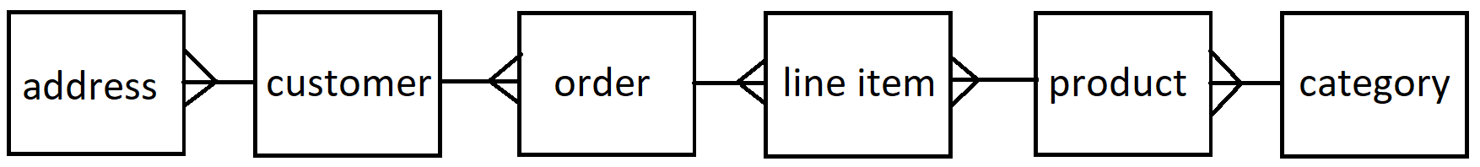

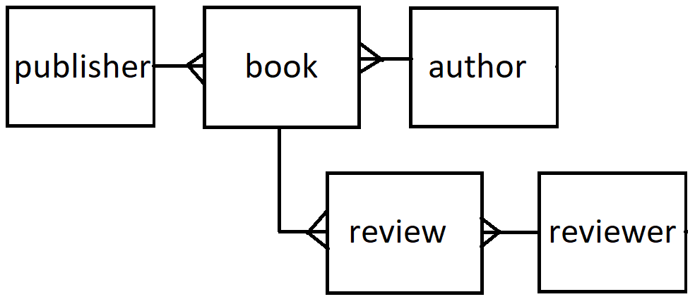

# Customer

Customer and reviewer here can be the same table and they represent a user in this system.

# Book

A book in abstract more generally a ‘product’ has many copies or ‘line items’ which you are going to sell. ‘Products’ or books are what a user sees when they navigate through the online bookshop but it is copies of ‘line items’ that they actually buy.

# Order

An order is what associates the customer with books for which line items are to be delivered.

# Implementation

This program is best written with a database as there is strong coupling of information.

If a simpler design is desired, please feel free to adapt.

Any amount of complexity can be built on top of this for example by:

* Extending the database to include more information
* Writing responsive CSS for different devices
* Sending messages to people making them aware of status updates (e.g. new appointment)

# Additional things to think about

Passwords for admins

Sessions (security restrictions)

Error handling

User interface / Experience

Testing

Documentation (User guide / walkthrough && readme)

Responsive CSS

# Technologies needed

Angular

C# (Visual Studio web app project)

SQL

# Extended version:

https://codeshoppy.com/shop/product/online-book-store/